**Calculator Assumed**

**General Continuous Random Variables Mixed Applications**

Time: 45 minutes

Total Marks: 45

Your Score: / 45



**Question One: [2, 2, 2, 2, 3 = 11 marks] CA**

According to the Apple support site, the time taken to download a 2 hour movie using an ADSL2+ Broadband connection is uniformly between 18 and 24 minutes. Let T be the time taken to download one 2 hour movie from the Apple store.

(a) Sketch the probability distribution function for T.

(b) Calculate the mean time taken to download a movie.

(c) 75% of the time it takes less than *k* minutes to download a movie. Calculate the value of *k.*

(d) Calculate 

(e) This week, Dom has downloaded one movie each day. Determine the probability that exactly three of them took more than 22 minutes to download.

**Question Two: [3, 3 = 6 marks] CA**

Consider the probability density function of the random variable Y drawn below,  .

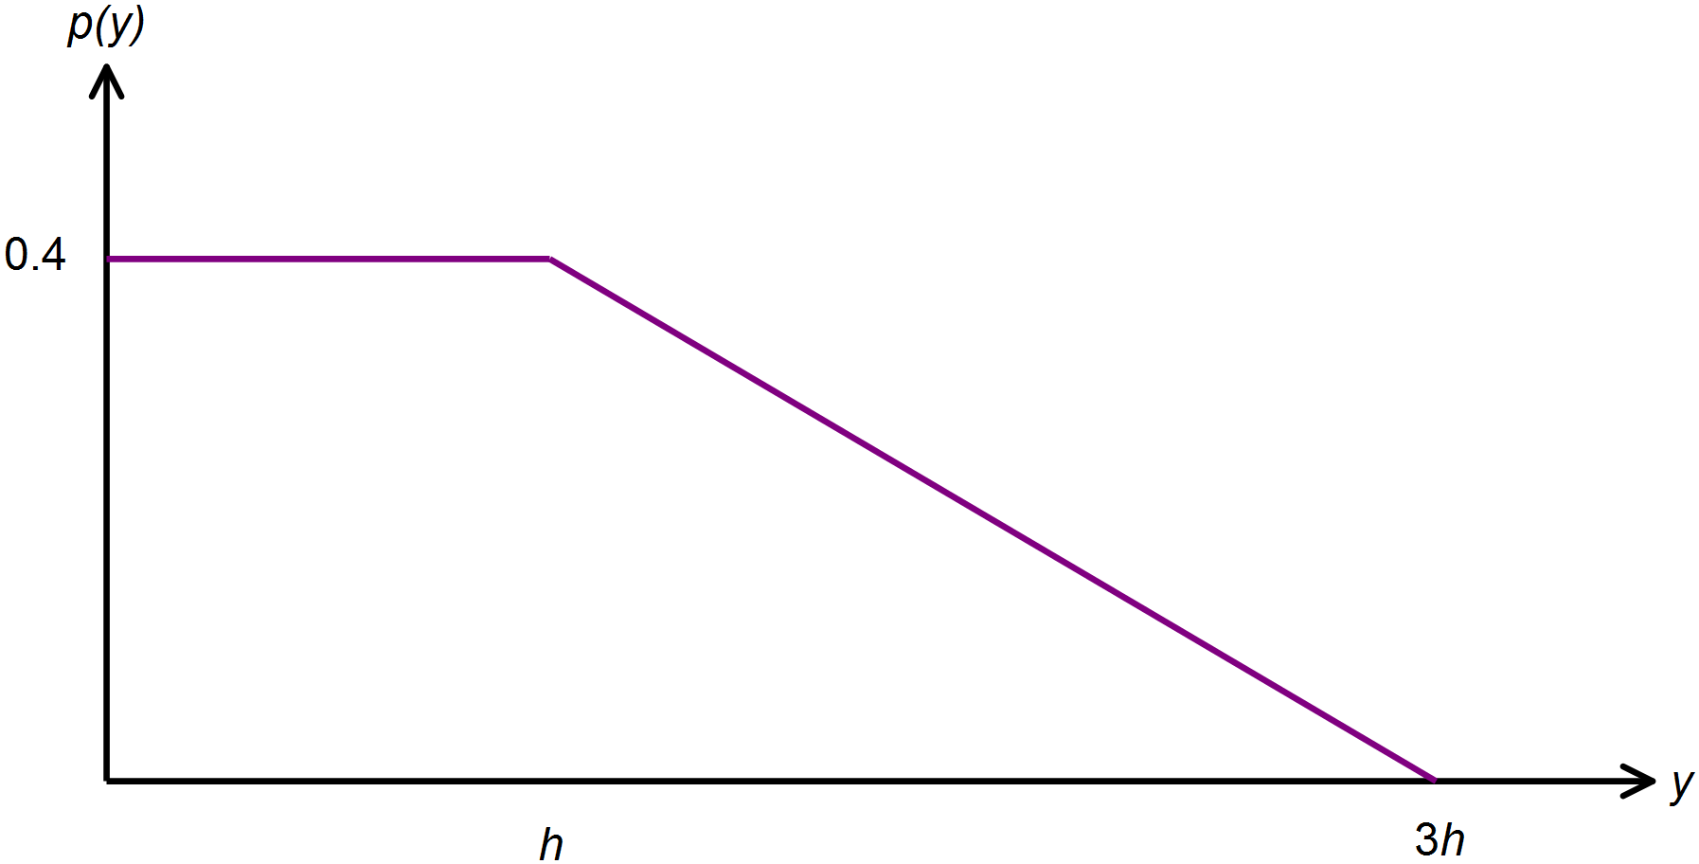(a) Calculate the value of *h.*

(b) Calculate *k* such that 

**Question Three: [2, 2, 3, 1, 3, 2, 2, 1, 1, 2 =19 marks] CA**

During December, a local shopping centre has a gift wrapping stall which is open 12 hours a day. On average, the gift wrapping stall serves 120 customers per day.

(a) What is the average length of time between serving each customer at this gift wrapping stall? Give your answer in minutes.

This scenario can be best modelled by an exponential probability density function which is given by  where  is the mean time between serving customers.

(b) Hence state the probability density function for X, where X represents the time between serving each customer.

(c) Show, using calculus methods, that your answer to part (b) does in fact represent a continuous probability density function.

(d) State the expected value of the distribution.

(e) Show, using calculus methods, that the standard deviation of the distribution is the same as the mean.

(f) If the time between serving customers was instead recorded in hours, determine the new mean and standard deviation of the distribution.

(g) Calculate the median waiting time, in minutes, between customers.

Calculate the probability that the next customer will be served:

(h) less than 5 minutes after the previous one.

(i) between 5 and 7 minutes after the previous one.

(j) less than 8 minutes after the previous one given that it took longer than 5 minutes.

**Question Four: [3, 1, 2, 1, 2 = 9 marks ]**

The weight of a 7 week old kitten, in *x* grams, is a continuous random variable where the probability function is given by: 

(a) Show using calculus techniques that  .

(b) Determine the probability that a 7 week old kitten is less than 300 grams.

(c) Calculate the expected weight of a randomly selected kitten.

(d) Calculate the expected weight of a randomly selected kitten if the weights were recorded in kilograms.

(e) Calculate the probability that a kitten weighing less than 400 grams weighs more than 300 grams.

**SOLUTIONS**

**Calculator Assumed**

**General Continuous Random Variables Mixed Applications**

Time: 45 minutes

Total Marks: 45

Your Score: / 45



**Question One: [2, 2, 2, 2, 3 = 11 marks] CA**

According to the Apple support site, the time taken to download a 2 hour movie using an ADSL2+ Broadband connection is uniformly between 18 and 24 minutes. Let T be the time taken to download one 2 hour movie from the Apple store.

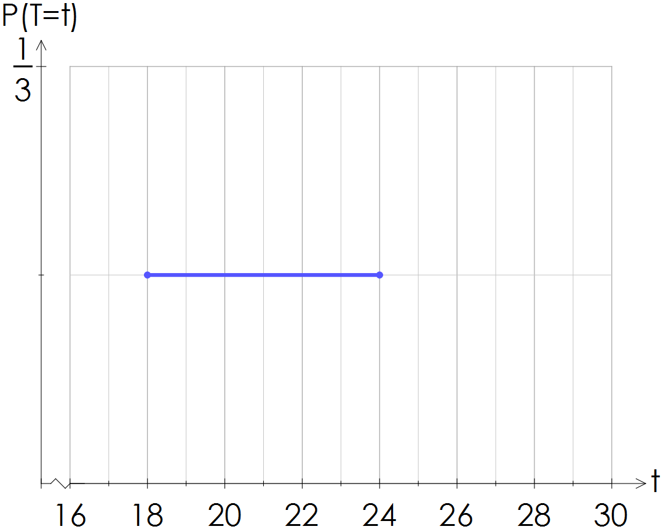(a) Sketch the probability distribution function for T.





(b) Calculate the mean time taken to download a movie.

 

(c) 75% of the time it takes less than *k* minutes to download a movie. Calculate the value of *k.*



(d) Calculate 

 

(e) This week, Dom has downloaded one movie each day. Determine the probability that exactly three of them took more than 22 minutes to download.

 

**Question Two: [3, 3 = 6 marks] CA**

Consider the probability density function of the random variable Y drawn below,  .

(a) Calculate the value of *h.*



(b) Calculate *k* such that 

 

**Question Three: [2, 2, 3, 1, 3, 2, 2, 1, 1, 2 =19 marks] CA**

During December, a local shopping centre has a gift wrapping stall which is open 12 hours a day. On average, the gift wrapping stall serves 120 customers per day.

(a) What is the average length of time between serving each customer at this gift wrapping stall? Give your answer in minutes.

 

This scenario can be best modelled by an exponential probability density function which is given by  where  is the mean time between serving customers.

(b) Hence state the probability density function for X, where X represents the time between serving each customer.

 

(c) Show, using calculus methods, that your answer to part (b) does in fact represent a continuous probability density function.

 

(d) State the expected value of the distribution.

 

(e) Show, using calculus methods, that the standard deviation of the distribution is the same as the mean.

 

(f) If the time between serving customers was instead recorded in hours, determine the new mean and standard deviation of the distribution.

 

(g) Calculate the median waiting time, in minutes, between customers.

 

Calculate the probability that the next customer will be served:

(h) less than 5 minutes after the previous one.

 

(i) between 5 and 7 minutes after the previous one.

 

(j) less than 8 minutes after the previous one given that it took longer than 5 minutes.

 

**Question Four: [3, 1, 2, 1, 2 = 9 marks ]**

The weight of a 7 week old kitten, in *x* grams, is a continuous random variable where the probability function is given by: 

(a) Show using calculus techniques that  .

 

(b) Determine the probability that a 7 week old kitten is less than 300 grams.

 

(c) Calculate the expected weight of a randomly selected kitten.

 

(d) Calculate the expected weight of a randomly selected kitten if the weights were recorded in kilograms.

 

(e) Calculate the probability that a kitten weighing less than 400 grams weighs more than 300 grams.

 